ADVANCE PYTHON PROGRAMMING
LAB STASK-18

NAME:MOHAMED RIYAS Y
REGNO:22MID0218

- VS Code is a open-source code editor developed by Microsoft that supports multiple programming languages and extensions.
- Code Runner is a VS Code extension that allows you to quickly run code snippets or entire files from within the editor without using a terminal manually.
- GitHub Copilot in VS Code is an AI-powered coding assistant that suggests code completions, functions, and documentation in real time as you type.

TEXTBLOB:
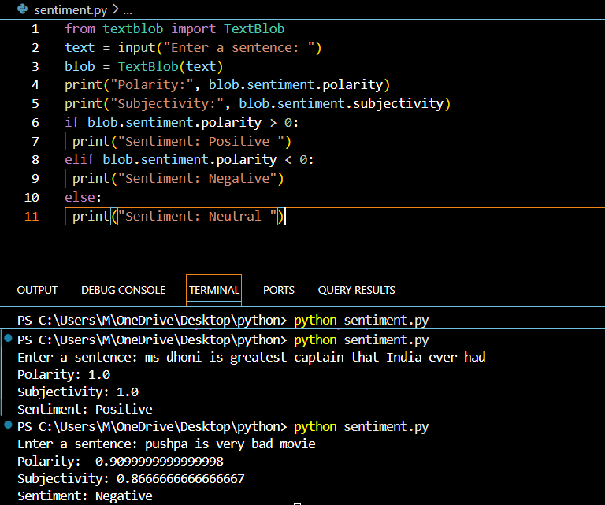
MATPLOTLIB:
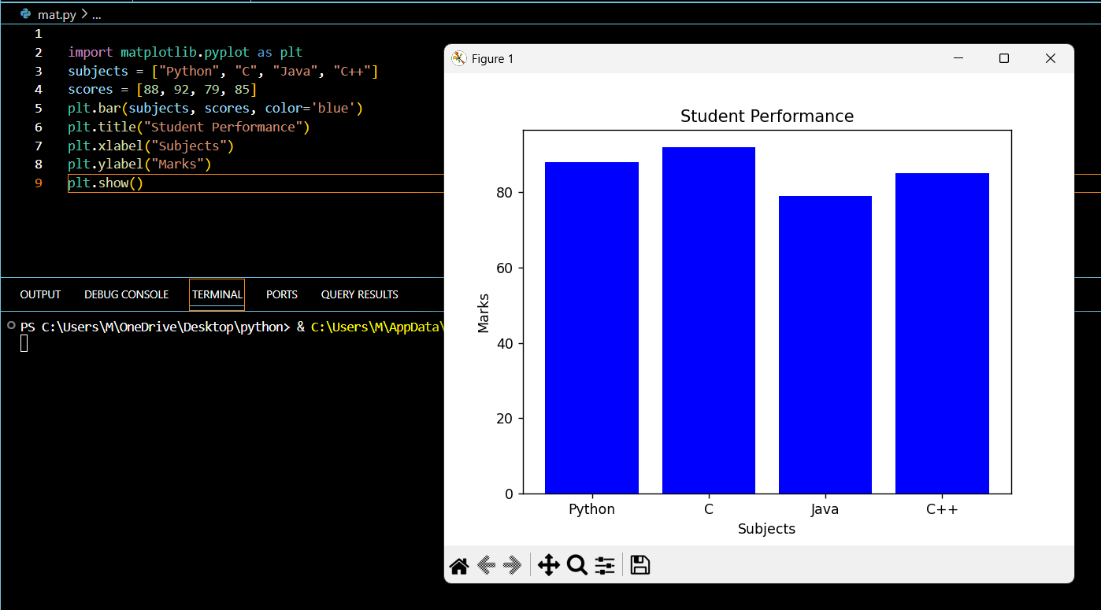
QR:
